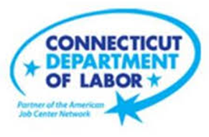

**NEW WEEKLY JOB POSTINGS FROM   
HELP WANTED ONLINE  
Office of Research**

**Week Ending November 13th, 2021:   
New Ads at Four Month Low, But Are More Than Double November 2020 Levels**

WETHERSFIELD, November 19th, 2021 – During the week ending November 13th, there were 7,155 new postings, down 1,649 new ads or -19% from a week ago. Most of this decline occurred in Retail Trade, down 793 and within that sector, most of the decline occurred at Amazon (-603). Occupations with the largest over the week declines include Laborer & Freight Material Movers (-378), Registered Nurses (-372 new ads), and Tractor Trailer Truck Drivers (-107 new ads). The most recent week of new ad data is the lowest level since mid-August but still more than twice the new ad level from a year ago, which was 3,366 new ads during the second week of November 2020.  
 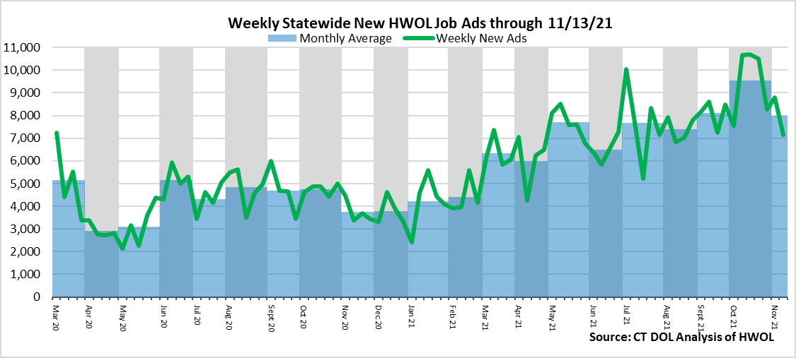

**Industries** with the most new postings include Health Care & Social Assistance, Retail Trade, and Finance & Insurance.

**Occupations** with the most new postings include Registered Nurses, Retail Salesperson, and Laborers, Freight, & Material Movers.

**Employers** with the most new postings include Amazon, Hartford Healthcare, and UKG Ultimate Kronos Group.

**The three industries with the most new job postings where**

* **Health Care & Social Assistance** (1,430 new postings, -12% over the week)
* **Retail Trade** (974 new postings, -45% over the week)
* **Finance & Insurance** (658 new postings, +8% over the week)

  
 Fourteen sectors had job posting decreases over the week, one was unchanged, and six had increases. The fourteen decreasing sectors fell by a combined 1,802 new ads and the six increasing ones grew by a combined 153. The largest industry decreases occurred in Retail Trade (-793 new ads), Health Care & Social Assistance (-193 new ads), and Accommodation & Food Services (-106 new ads). These three sectors accounted for 61 percent of the losses experienced in declining sectors. The Retail Trade losses follow a 620 new ad increase over the week ending November 6th. The six increasing sectors grew by 50 new ads or less over the week, with the three largest being Finance & Insurance (+50 new ads), Manufacturing (+34 new ads), and Information (+32 new ads).  
  
 For more information on total job ads by industry for Connecticut and its labor market areas, see the monthly report available here: <https://www1.ctdol.state.ct.us/lmi/hwol.asp>

**New Job Postings by Occupation**



**The occupations with the most new postings were:**

* Registered Nurses (374 new postings, -17% over the week)
* Retail Salespersons (252 new postings, -26% over the week)
* Laborers & Freight, Stock & Material Movers (185 new postings, -67% over the week)

**Employers with the Most New Job Postings** 

Employers with the most new job postings during the week were mostly in Retail Trade, Finance & Insurance, and Professional, Scientific, & Technical Services. The 25 employers shown above account for 23 percent of all new ads.   
Of the top 25, 17 had over the week ad increases and 8 had decreases, the largest of each being UKG Ultimate Kronos Group (+137 new ads) and Amazon (-603 new ads). The 17 increasing employers in the top 25 amounted to a combined 694 new ad increase over the week, and the 8 decreasing employers were down a combined 794, resulting in a -100 over the week change. Almost all of the over the week decline in the top 25 was due to Amazon, which accounted for 76% of the drop among the 8 decreasing employers.

**What is HWOL?**The **Conference Board Help Wanted Online**® Data Series (HWOL) measures the number of new, first-time Online job postings and jobs reposted from the previous month for over 16,000 Internet job boards, corporate boards and smaller job sites that serve niche markets and smaller geographic areas. To view more HWOL data, go to: [**https://www1.ctdol.state.ct.us/lmi/pubs/HWOL2020.pdf**](https://www1.ctdol.state.ct.us/lmi/pubs/HWOL2020.pdf)